

**►**

If Doing This Activity With Young Children:  
*Have an adult assemble it first (using this build guide), and then give to children to tinker and engineer with.*

**[](http://www.demco.com/goto?teachergeek_ins&intcmp=TG_Instructions)**

**WARNING!**Small Parts, Choking Hazard,   
For ages 4 and Up.   
Use only with Adult Supervision.

*To download documents,* [*click here*](http://www.demco.com/goto?teachergeek_ins&intcmp=TG_Instructions)*.*



You’ll need these components to create one Gears & Pulleys Tinker Set.

|  |  |  |
| --- | --- | --- |
|  | Colors will vary. |  |
| **8 – Pulleys** Two of the following pulleys:  9mm, 25.5mm, 55.5mm, 70mm | **8 – Gears**  Two each of the following gears:  10, 20, 40, 50 Tooth | **2 – Blocks** |
| **x10** |  |  |
| **2 – Hole Plates** | **4 – Dowels**  5mmx300mm (12in) | **6 – Rubber Bands**  Small (#16) |



This isn’t a kit. With TeacherGeek, you get to really build (*cut, ream, screw*).  
Here are tools you’ll need to get started. They can be shared, between kids/groups, if needed.

* *[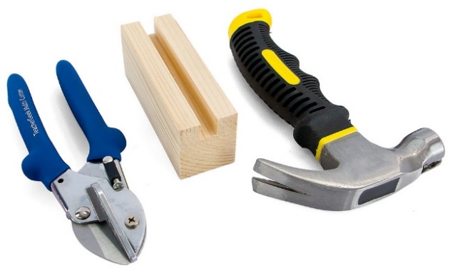](http://www.demco.com/goto?browse&key=teachergeek&key=tools&intcmp=TG_Tools)***TeacherGeek Multi-Cutter**
* **Tapping Block**
* **Small Hammer**



**Tip:** Save all your materials (even what you cut off). Keep them in a bag. They can be used later.

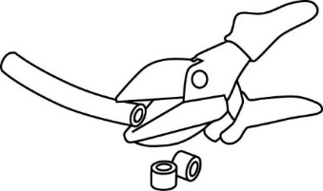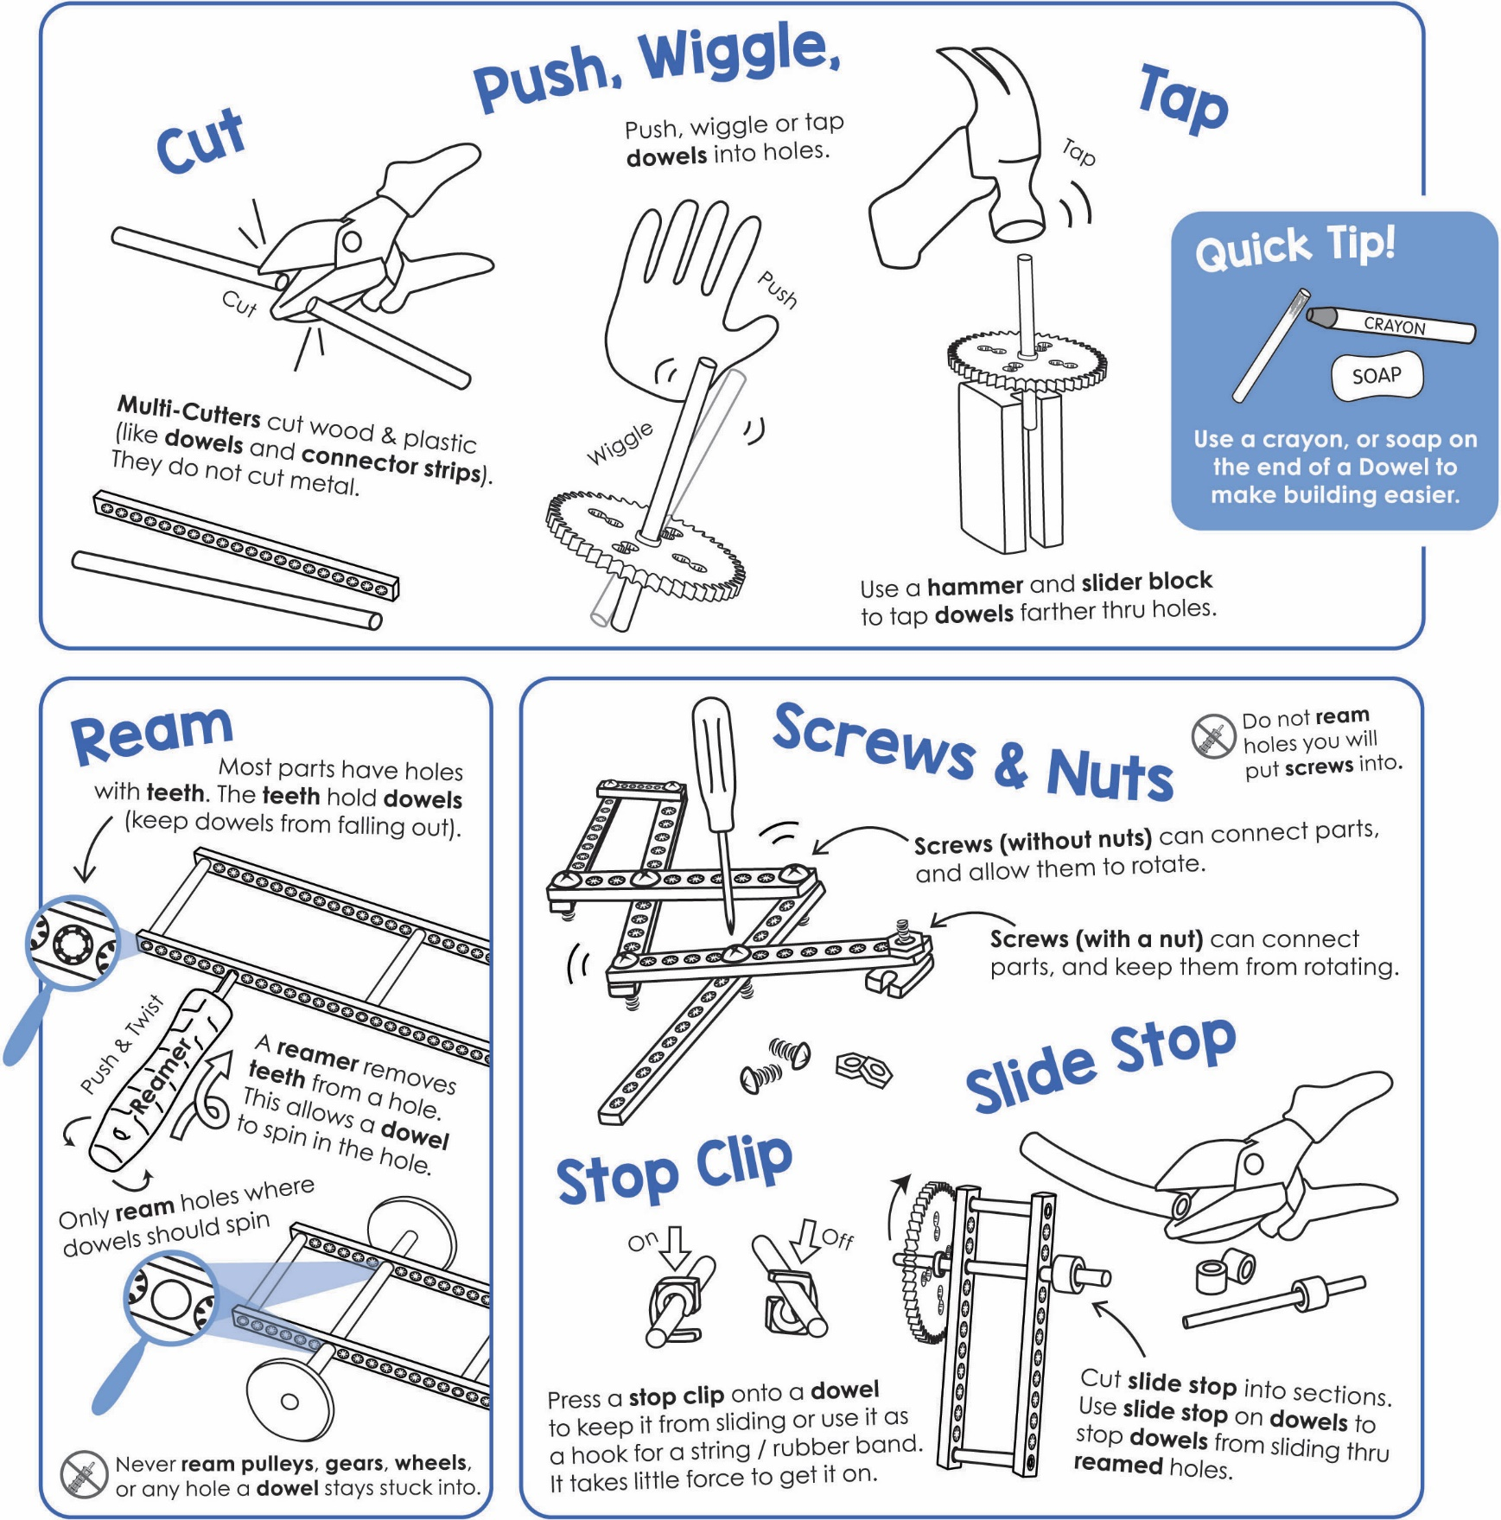

Get individual tools, or the complete  
[**TeacherGeek / Maker Tool Set**](http://www.demco.com/goto?browse&key=teachergeek&key=tools&intcmp=TG_Tools)

Tools for ages 13 and above, or with adult super vision





**Tap** or push the **dowels** into two, stacked, upside-down **hole plates**.



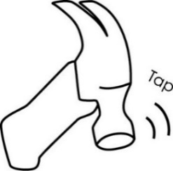**Cut** four **3cm** (1in) **dowels**.

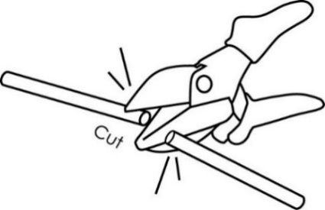

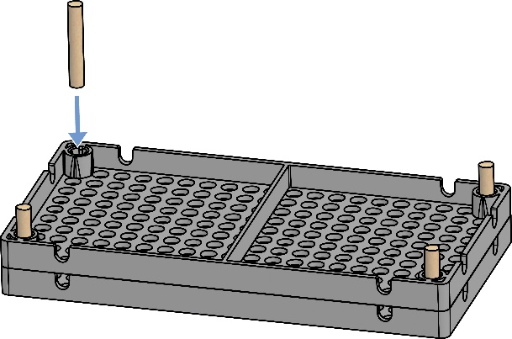



3cm (1in)

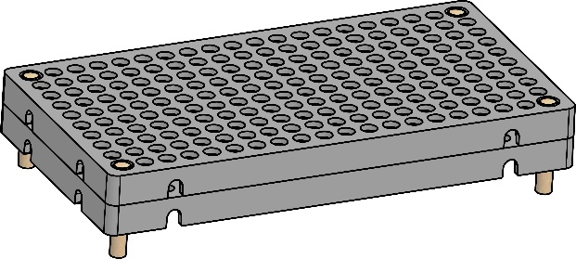

**Congratulations!**

Your **base** is done.

**►**

Now, it’s time to prepare your gears and pulleys.

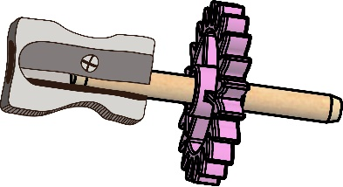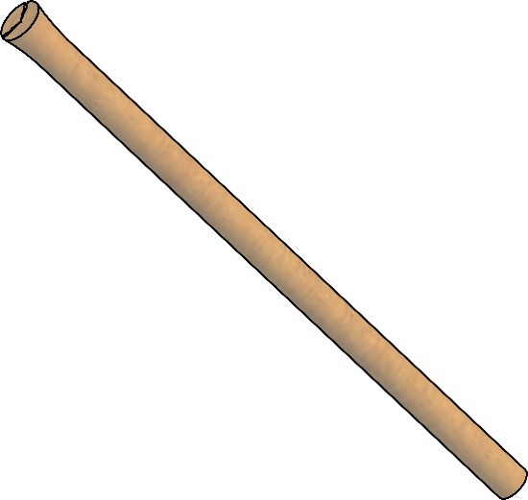

**►**

**Tip:** Use a pencil sharpener to clean up damaged dowel ends. Don’t sharpen it to a point; only take a little off.

Damaged dowel end

Dowel End fixed with a pencil sharpener

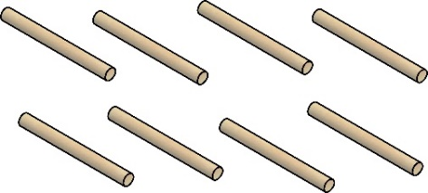****

5cm (2in)

**Cut** two **5cm** (2in) **dowels**.   
These will become **shafts** for gears.



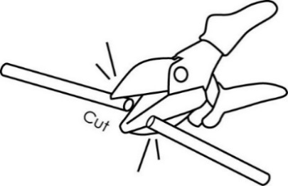

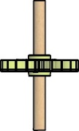****

*Finished Gears*

**Tap** a **shaft** into each gear’s **center hole**, so the gear is in the center of the shaft.



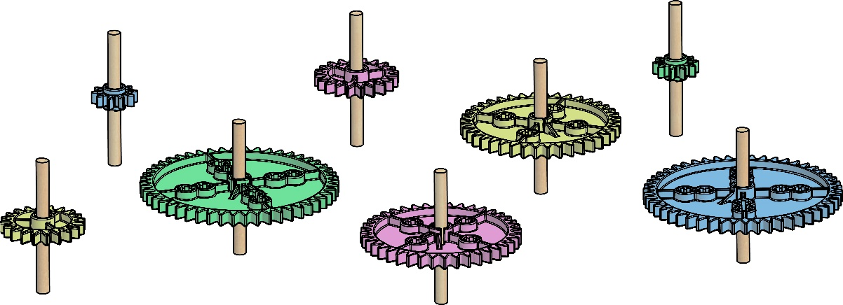

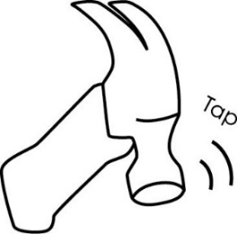

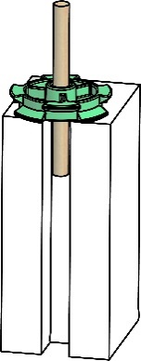



**Tap** a **shaft** into each pulley center hole,   
so the pulley is in the center of the shaft.

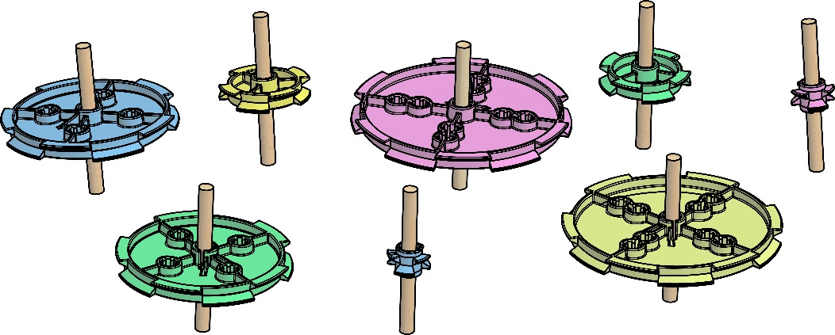

**►**

**Tip:** Tap the dowel through the gear   
or pulley, and down   
into the groove   
on a tapping block.

*Finished Pulleys*



A gear is a wheel with teeth. The teeth **mesh** (connect) with other gears.



Tooth

Meshed Teeth





Place **gears** into the base. Position them so that the teeth **mesh**. If gears are too close, or too far away, the teeth will not mesh correctly.



Keep experimenting… Rearrange how the   
gears mesh.

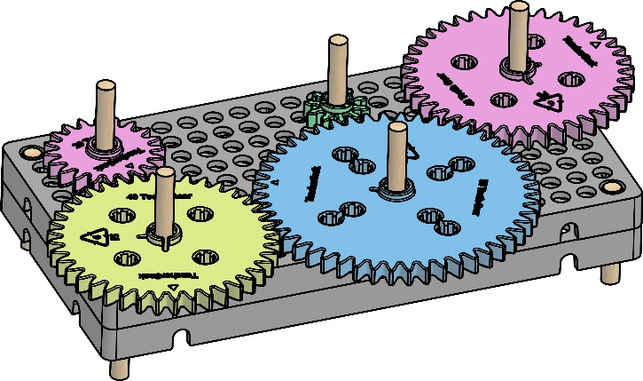

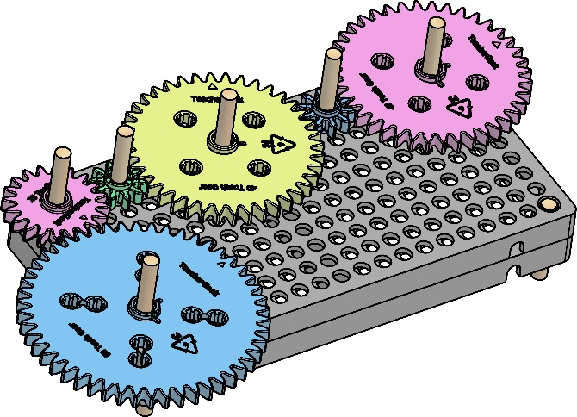





Place **pulleys** into the base. They should not touch   
each other. Use **rubber bands** (belts) to connect them.

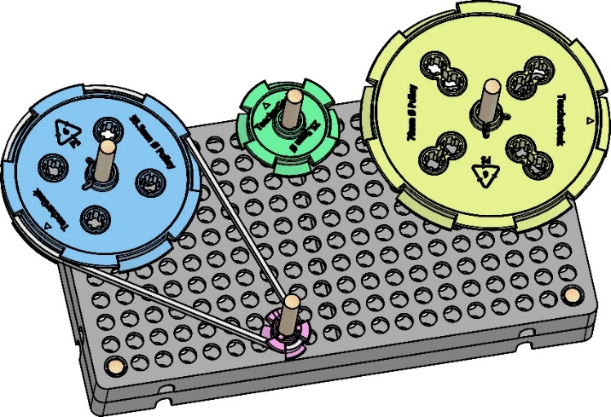

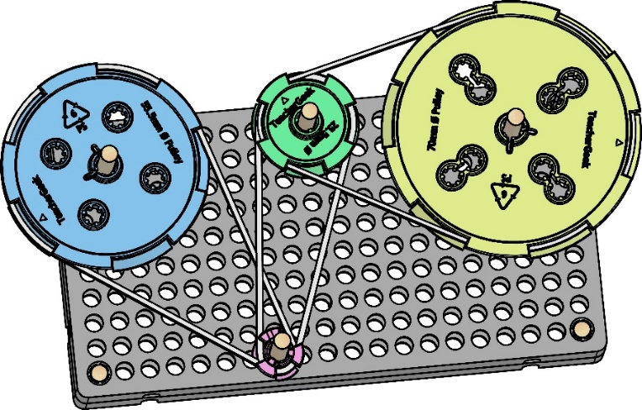





Want more room to play with gears and pulleys?

**Bases** can be **combined** using **blocks**.

****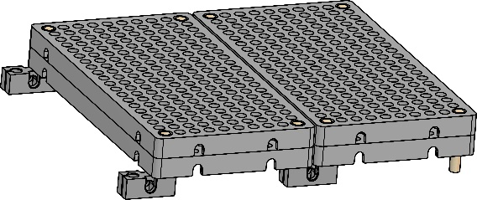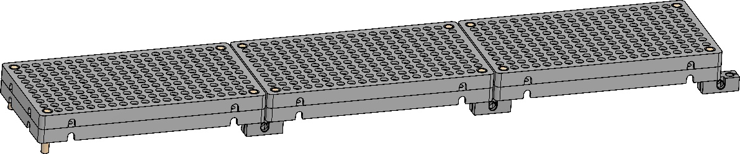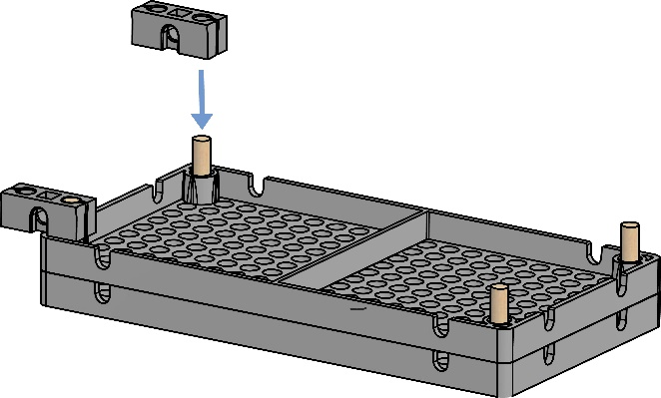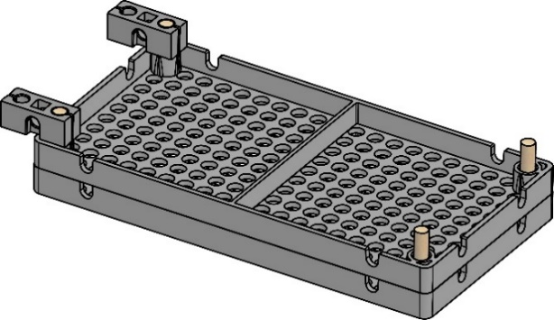



If you are going to do the optional Ratio Lab, now’s the time.

Bases can be combined long, or wide.

block



**►**

**Tip:** Place a mark on the outside of each gear and pulley. This will help you keep track of how far it **rotates** (like a hand on a clock).

Add paper, drawings, string and clay to the dowels to create **kinetic** (moving) sculptures.

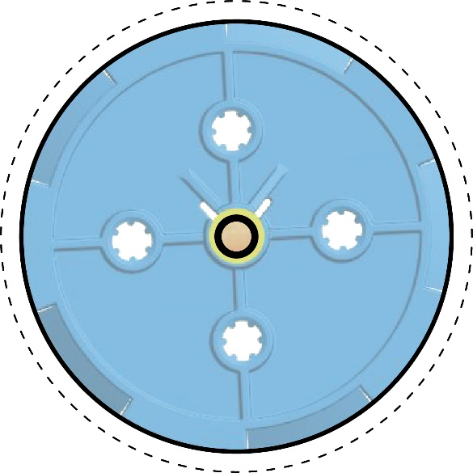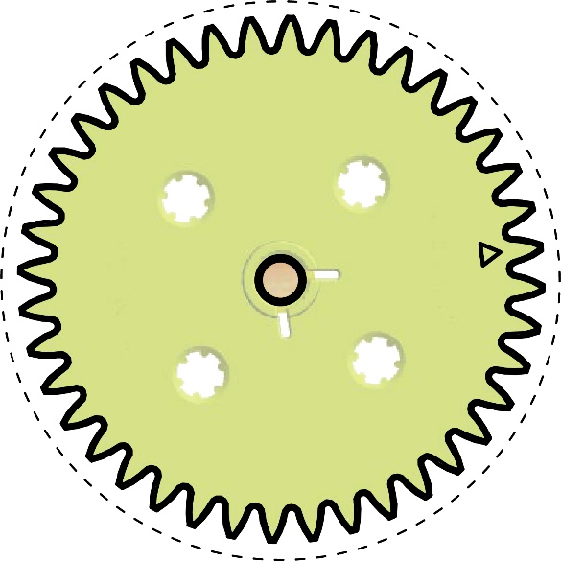



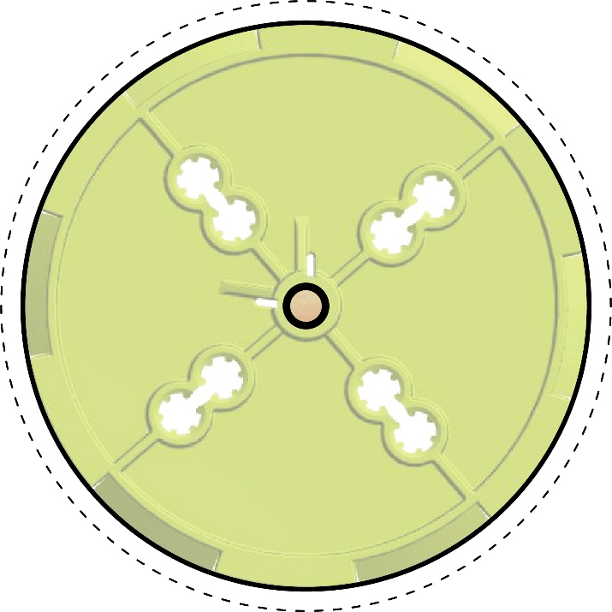

**►**

Cut the gears and pulleys   
on the dotted line. Don’t worry about the gear teeth. Use the paper cut-outs to experiment with designs and ideas for   
your tinker sets and sculptures.