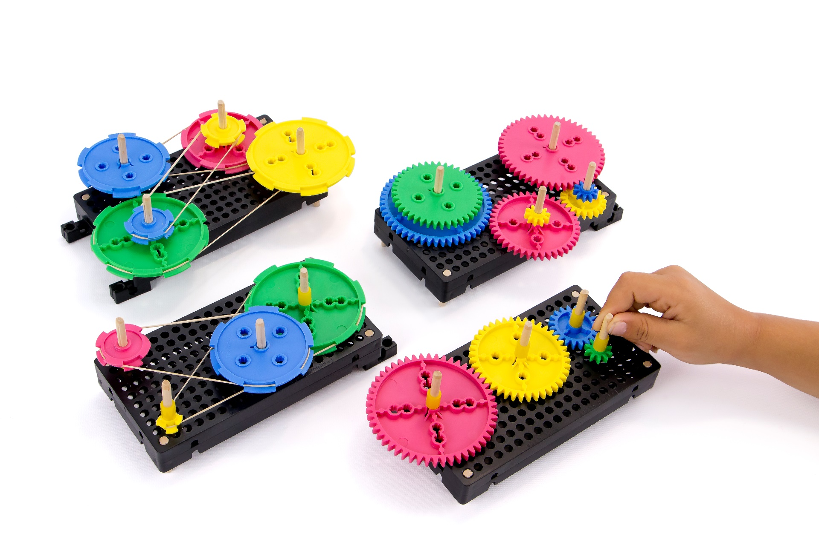

**►**

If Doing This Activity With Young Children:  
*Have an adult assemble it first (using this build guide), and then give to children to tinker and engineer with.*

**[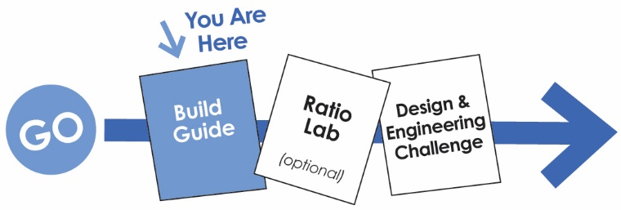](http://www.demco.com/goto?teachergeek_ins&intcmp=TG_Instructions)**

**WARNING!**Small Parts, Choking Hazard,   
For ages 4 and Up.   
Use only with Adult Supervision.

*To download documents,* [*click here*](http://www.demco.com/goto?teachergeek_ins&intcmp=TG_Instructions)*.*



You’ll need these components to create one Gears & Pulleys Tinker Set.

|  |  |  |
| --- | --- | --- |
| *Colors will vary.* |  |  |
| **8 – Pulleys** Two of the following pulleys:  9mm, 25.5mm, 55.5mm, 70mm | **8 – Gears**  Two of the following gears:  10, 20, 40, 50 Tooth | **2 – Blocks 1– Slide Stop** |
| **x10** |  |  |
| **2 – Hole Plates** | **4 – Dowels**  5mmx300mm (12in) | **6 – Rubber Bands**  Small (#16) |



This isn’t a kit. With TeacherGeek, you get to really build (*cut, ream, screw*).  
Here are tools you’ll need to get started. They can be shared, between kids/groups, if needed.

* *[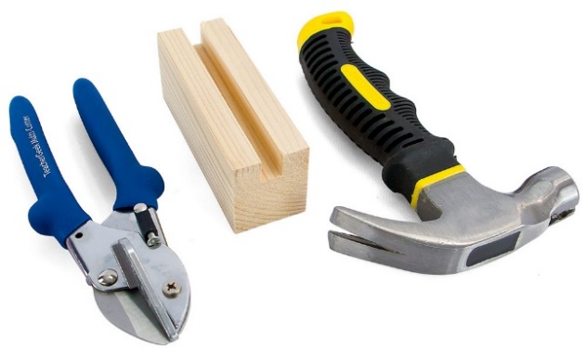](http://www.demco.com/goto?browse&key=teachergeek&key=tools&intcmp=TG_Tools)***TeacherGeek Multi-Cutter**
* **Tapping Block**
* **Small** [**Hammer**](https://teachergeek.com/products/stubby-claw-hammer)



**Tip:** Save all your materials (even what you cut off). Keep them in a bag. They can be used later.

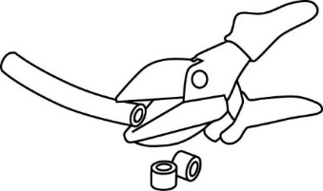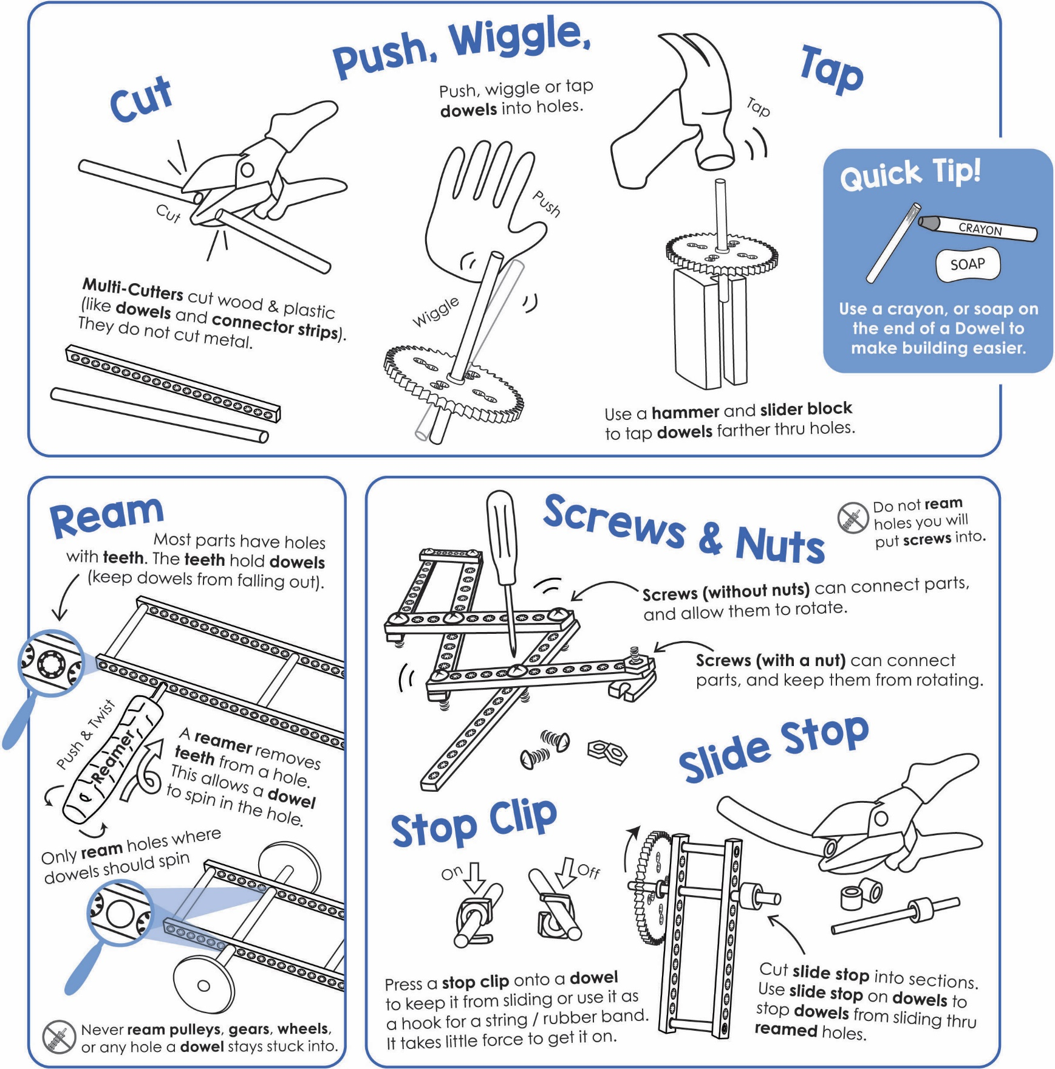

Get individual tools, or the complete  
[**TeacherGeek / Maker Tool Set**](http://www.demco.com/goto?browse&key=teachergeek&key=tools&intcmp=TG_Tools)

Tools for ages 13 and above,   
or with adult supervision





**Tap** or push   
the **dowels** into   
two, stacked, upside-down   
**hole plates**.

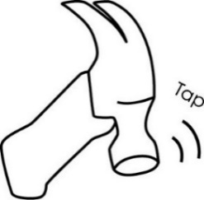**Cut** four **3cm** (1in) **dowels**.

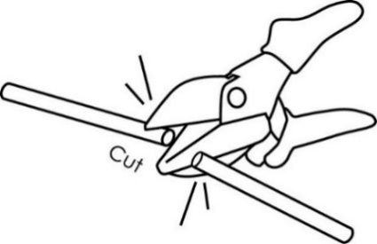

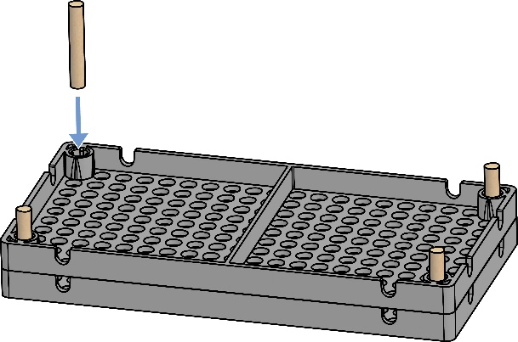

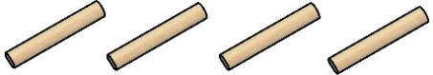

3cm (1in)

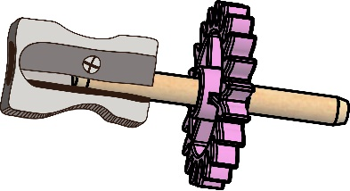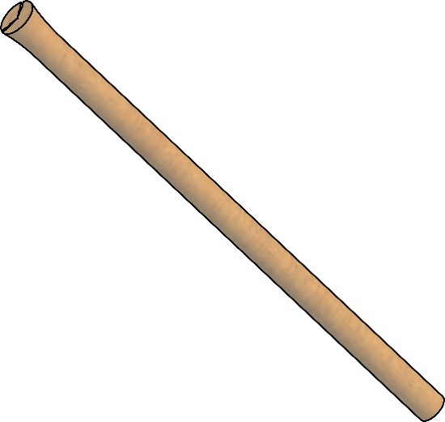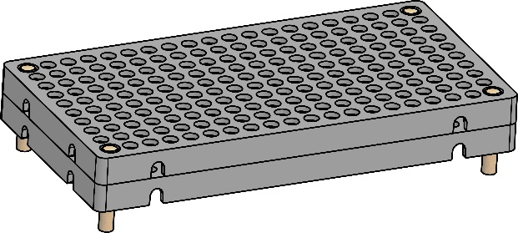

Dowel End fixed with a pencil sharpener

**Tip:** Use a pencil sharpener to clean up damaged dowel ends. Don’t sharpen it to a point; only take a little off.

Damaged Dowel End

**Congratulations!**

Your **base** is done.





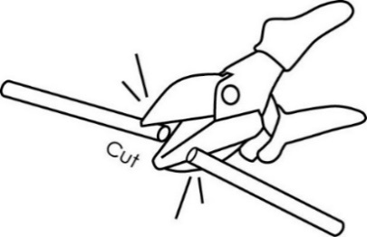

**Cut** two **5cm** (2in) **dowels**.   
These will become **shafts** for gears.

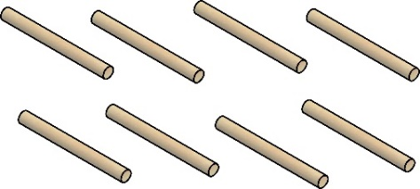

5cm (2in)

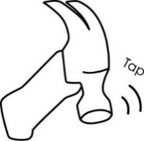

**Tip:** Tap the dowel   
through the center   
hole of a gear or pully, and down   
into the groove   
on a wooden   
**tapping block**.

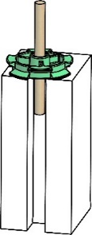



**Tap** a **shaft** into each gear center **hole**, so the gear is in the **center** of the shaft.

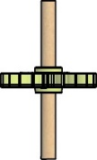

Gear on  
Center Shaft

*Each gear 0.5 cm tall*

**Stack** two **gears** on the dowel   
to create a **compound gear**.  
Slide one 0.5 cm piece of **slide stop** on single gear dowels – this will help   
each level, **mesh**.



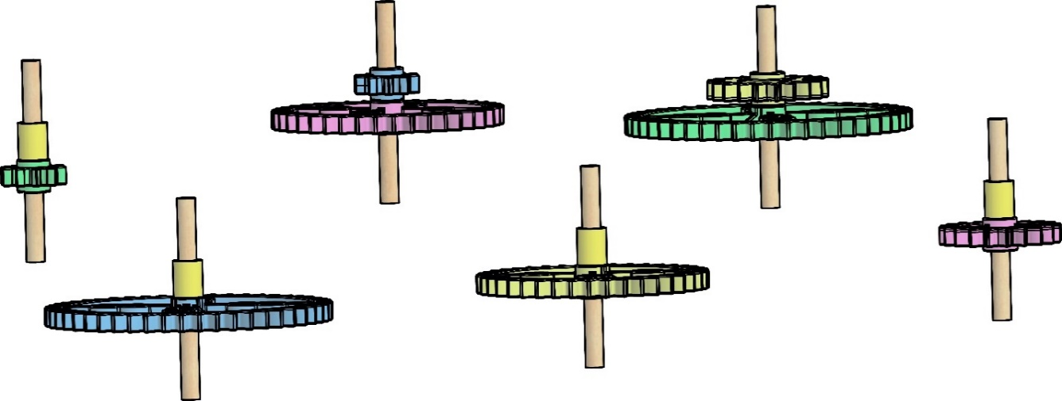

10 Tooth Gear

50-Tooth Gear

20-Tooth Gear

10-Tooth Gear

40-Tooth Gear

20-Tooth Gear

50-Tooth Gear

40-Tooth Gear

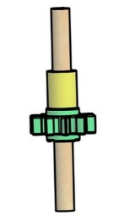

Slide Stop



*Finished Compound Gears*



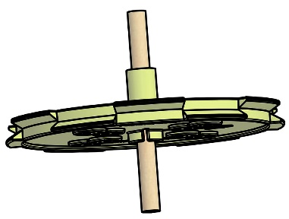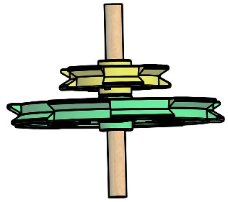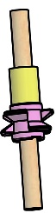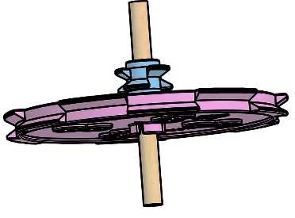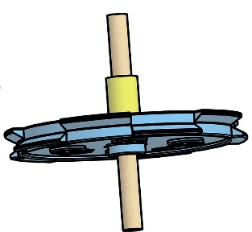

70mm  
Pulley

9mm  
Pulley

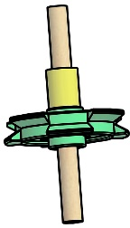

25.5mm  
Pulley

70mm  
Pulley

9mm  
Pulley

55.5mm  
Pulley

55.5mm  
Pulley

25.5mm  
Pulley

**Stack** two **pulleys** on   
the dowel to create   
a **compound pulley**.  
Slide one 0.5 cm piece of **slide stop** on single pulley dowels – this will help each level line up.



*Finished Compound Pulleys*



Place **gears** into the **base**. Position them so that the teeth **mesh**. If gears are too close, or too far away, the teeth will not mesh correctly.

A gear is a wheel with teeth. The teeth **mesh** (connect) with other gears.



Tooth

Meshed Teeth



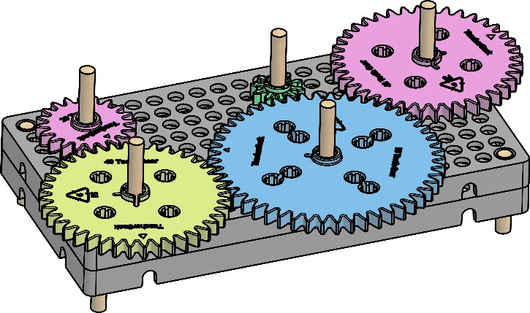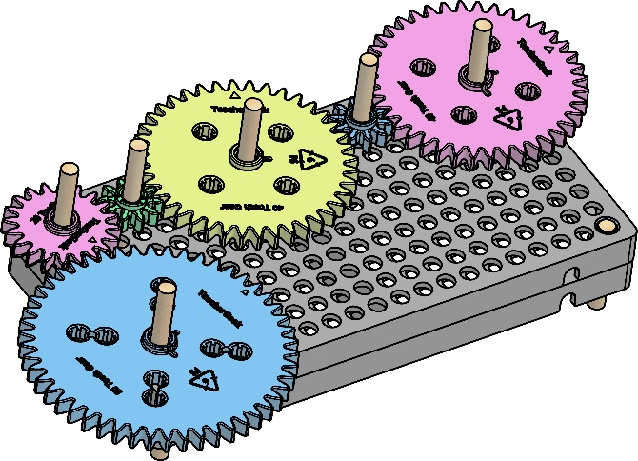

Keep experimenting… Rearrange how   
the gears mesh.



Place **pulleys** into the **base**. They should not touch each other. Use **rubber bands** (belts) to connect them.



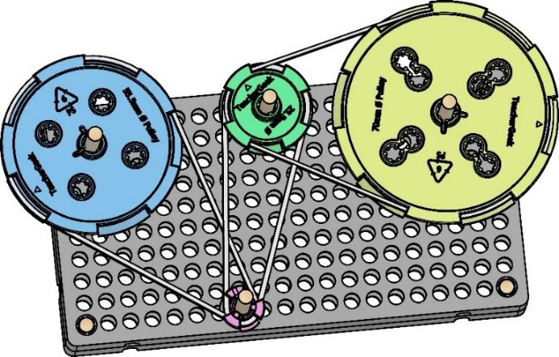

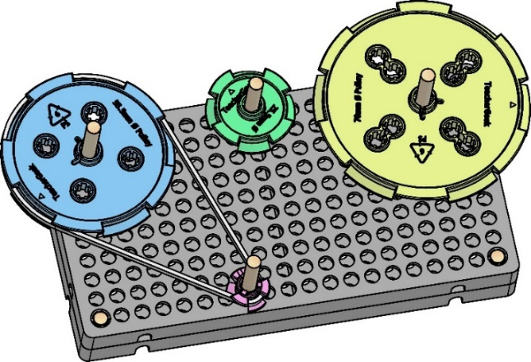

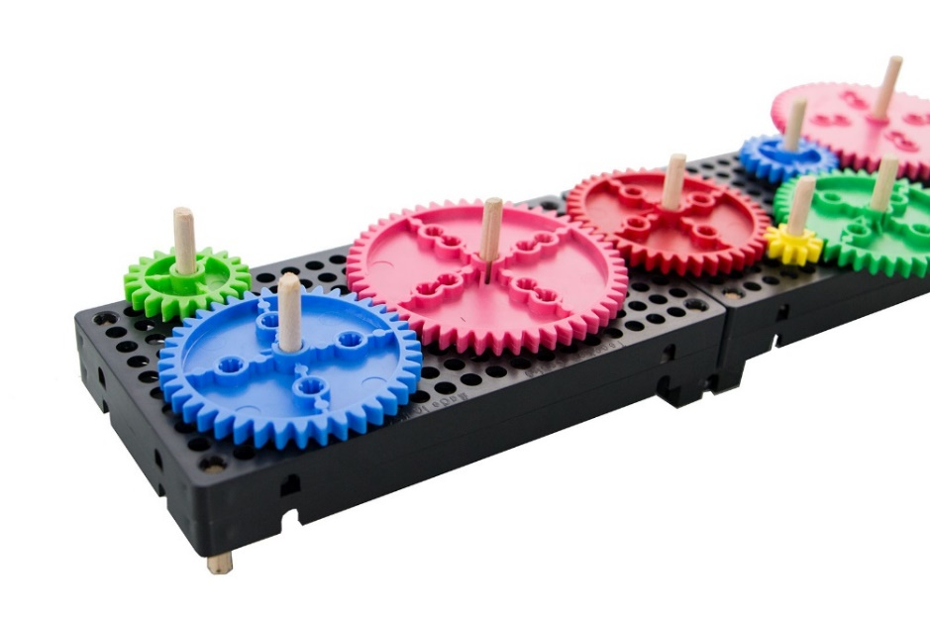





Want more room to play with gears and pulleys?  
Based can be combined using **blocks**.

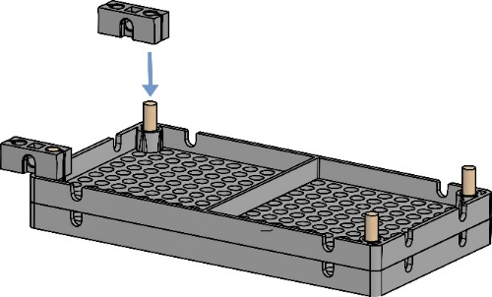

block

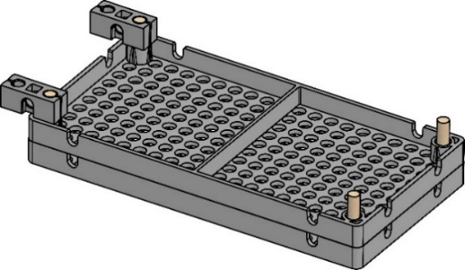



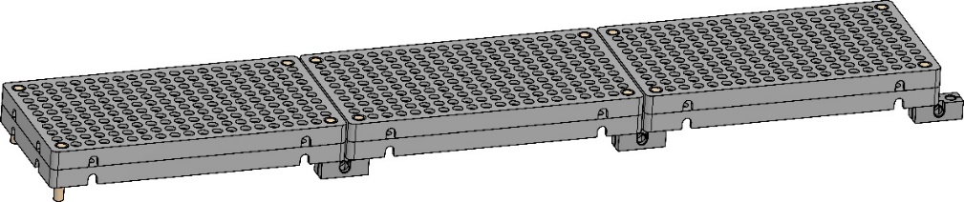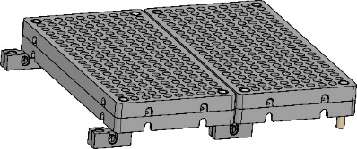

Bases can   
be combined   
long, or wide.



If you are going to do the optional Ratio Lab, now’s the time.

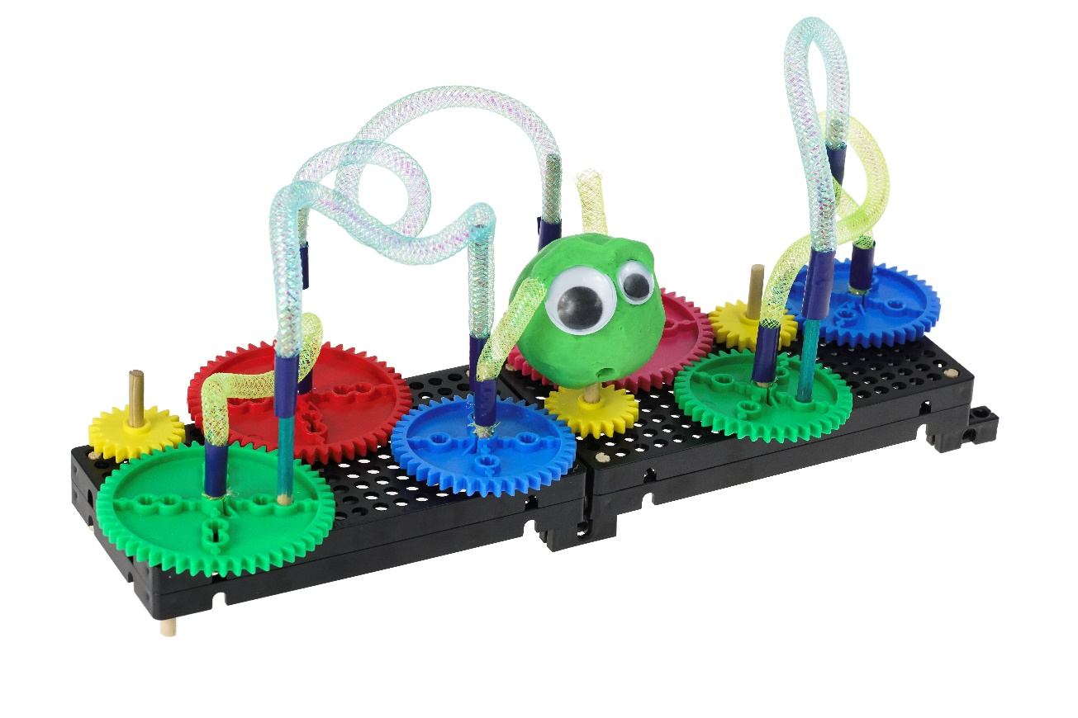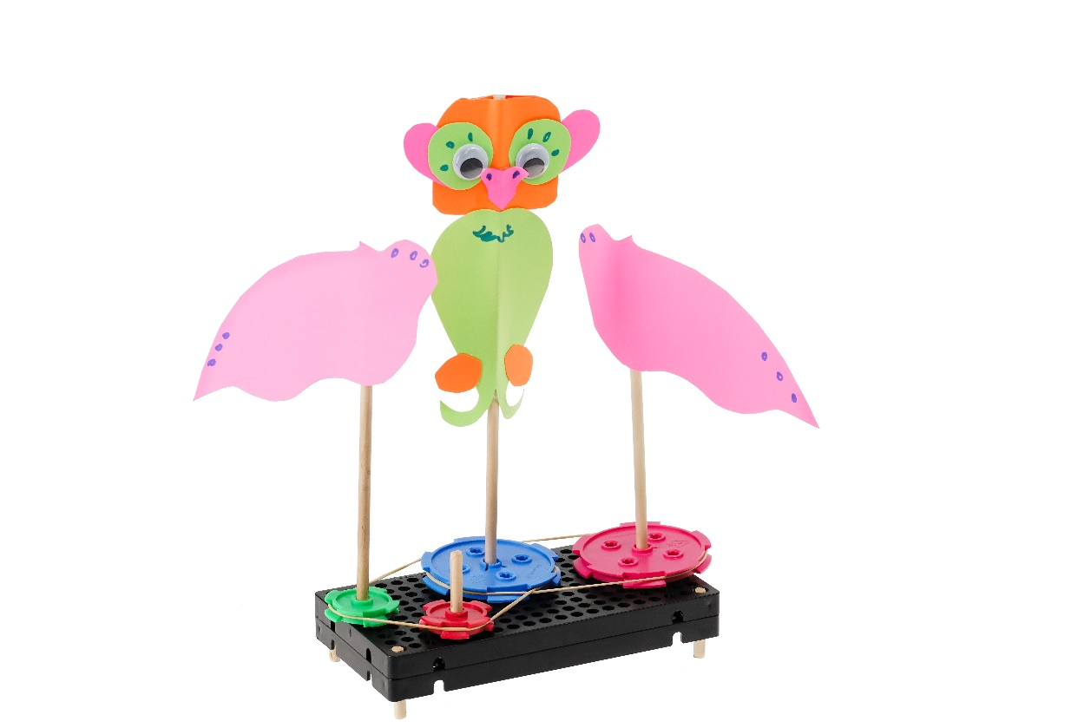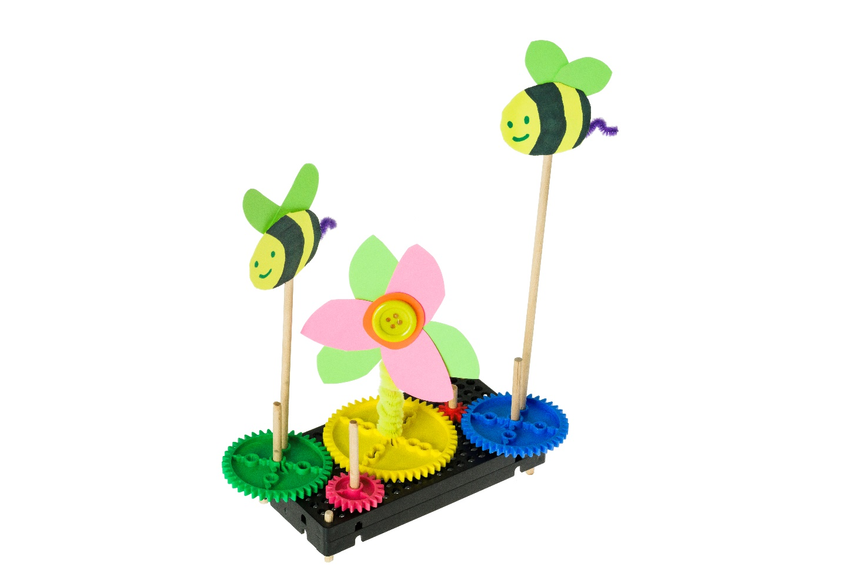

Add paper, drawings, string and clay to the dowels to create **kinetic** (moving) sculptures.



**Tip:** Place a mark on the outside of each gear and pulley. This will help you keep track of how far it **rotates** (like a hand on a clock).

**►**

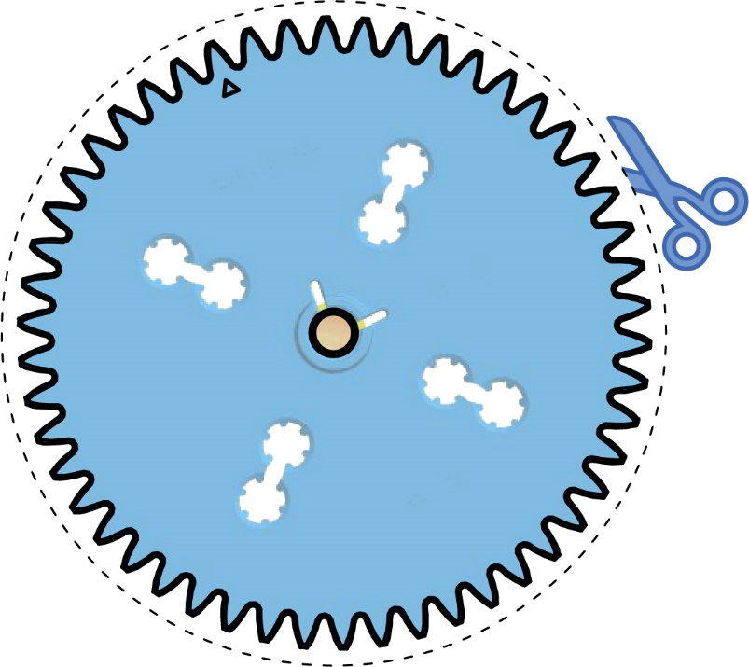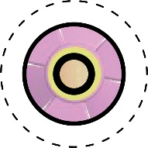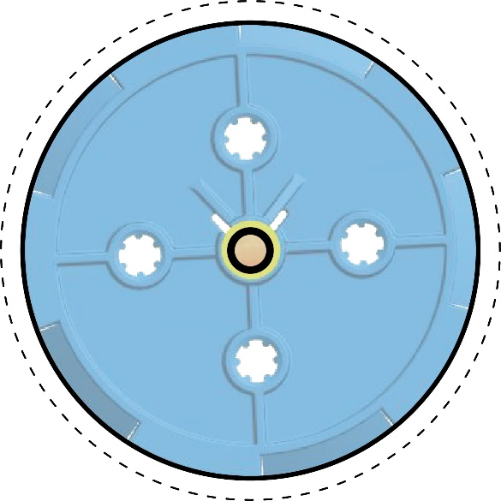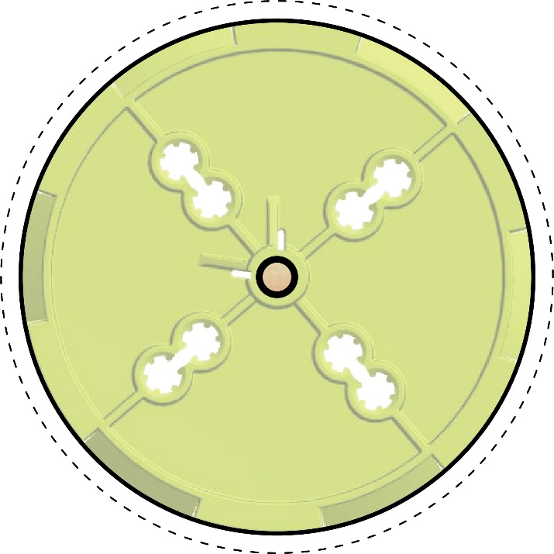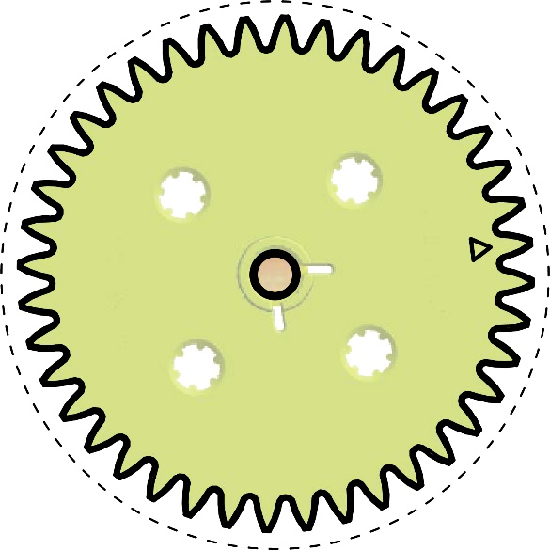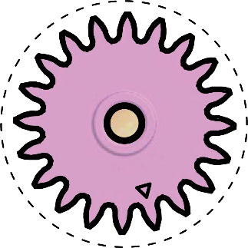

Cut the gears and pulleys   
on the dotted line. Don’t worry about the gear teeth. Use the paper cut-outs to experiment with designs and ideas for   
your tinker sets and sculptures.

**►**