This guide will take you through the process of creating an example yeast mobile. The example instructions intended to get you started. You are encouraged to re-design/engineer your own unique yeast mobile.

**How does the example yeast mobile work?**

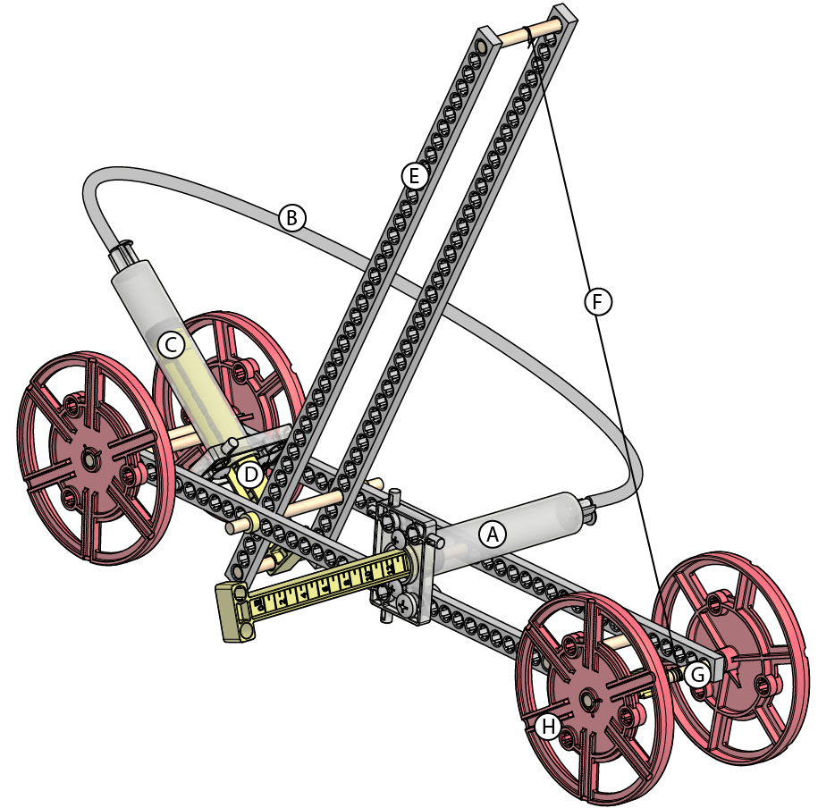

1. Pressure is created by the production of gas in chamber A
2. Pressure transfers to chamber C through line B (Pascal’s law)
3. Pressure in chamber C forces piston D down
4. Lever Arm E trades force generated by piston D for Distance (pulling string F)
5. String F wraps around Axle G, so when string F is pulled it unravels and turns axle G.
6. Axle G is connected to the wheels (H). The wheels turn when Axle G turns.

**Materials included in the TeacherGeek Yeast Mobile X2 Packs:**

|  |  |  |  |  |  |
| --- | --- | --- | --- | --- | --- |
| **Component** | **Picture** | **# in 10 Pack** | **# For a Single Advanced Arm** | **# Required to Build Example Arm** | **# Extra -To Innovate Your Own Design** |
| **Strip** |  | 60 | **6** | 4 | 2 |
| **Dowel** |  | 80 | **8** | 5 | 3 |
| **Tubing** |  | 3M  (10ft) | **Cut 28cm**  **(11in)** | Cut 28cm  (11in) | 0 |
| **Wheel** |  | 40 | **4** | 4 | 0 |
| **Stop Clip** |  | 20 | **2** | 1 | 1 |
| **Tire** |  | 20 | **2** | 1 | 1 |
| **Slide Stop**  **30cm (1ft)** |  | 3 | **Cut into 7cm (3in) Sections. Use a 7mm section per yeast mobile.** | | |
| **#10 1in**  **Screw** |  | 40 | **40** | 1 | 3 |
| **#6 x .5in Screw** |  | 60 | **6** | 6 | 0 |
| **#10 Nut** |  | 40 | **4** | 1 | 3 |
| **13ml Cylinder Barrel** |  | 20 | **2** | 2 | 0 |
| **13ml Cylinder Plunger** |  | 20 | **2** | 2 | 0 |
| **13ml Cylinder Piston** |  | 20 | **2** | 2 | 0 |
| **1cc Silicone Grease Packet** |  | 3 | **Share the Grease:**  **Use for all cylinders** | | |

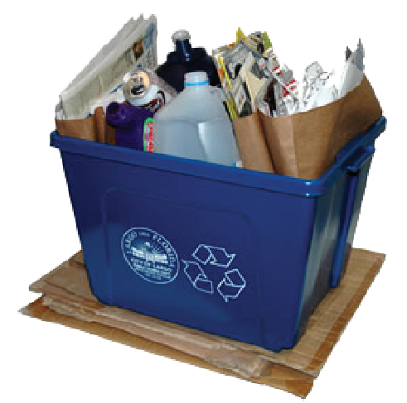**Other Materials:**

The TeacherGeek system is designed to be used with other materials you can find (materials not supplied in the TeacherGeek pack). Other materials could be craft supplies, from a recycling bin, wood, metal, cardboard, or anything else you may have. These materials can be used to help you create your own unique designs.

**Tools Required:**

|  |  |  |  |  |  |
| --- | --- | --- | --- | --- | --- |
| **Tool** | **Picture** | **Use** | **# Required** | **# Suggested for Classes** | **Alternate** |
| **Reamer** |  | Enlarge holes so dowels slide & rotate | 1 | 1 for every 3-4 students | 5.5mm or 7/32” drill bit and drill |
| **Multi-Cutter** |  | Cut wood, plastic, cardboard | 1 | 1 for every 3-4 students | Side Cutters, Saw, Pruning Shears |
| **Pliers** |  | Tighten nuts, pull out dowels | 1 -Optional | 1 for every 3-4 students | Wrench |
| **Phillips Screwdriver** |  | Turn screws | 1 | 1 for every 3-4 students |  |
| **Crayon or Wax** |  | Rub on dowel to make it slide easier into a hole | 1 -Optional | 1 for every 3-4 students | Wax |
| **Safety Glasses** |  | Protect eyes | 1 | 1 per student | Goggles |

**Age Level Recommendations:** 12 and above with adult supervision.

Adult Supervision Required.

**How does the TeacherGeek system work?**

**Dowels & Holes**

TeacherGeek components have holes that wooden dowels press securely into. If you are having trouble pushing a dowel into a hole, tap it with a hammer, the side of your closed cutter, or pliers.

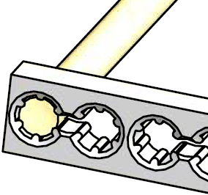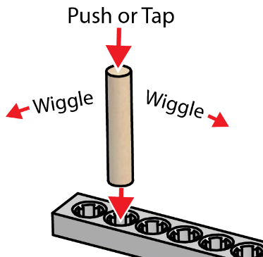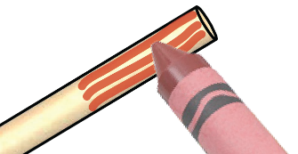

Tip: Rub a crayon or wax on the end of a dowel to make it slide easier into a hole.

**Reaming**

Ream holes to create a loose fit for dowels to rotate or slide. **Caution:** Do not ream holes that you want the dowel to stay pressed into. Dowels will fall out of reamed holes.

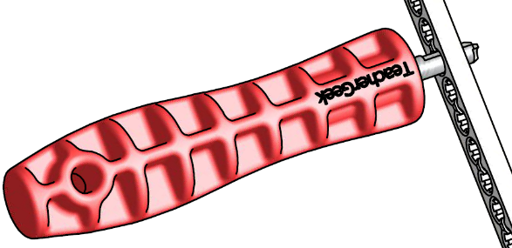 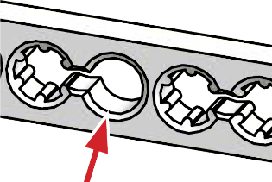

Reamer

Reamed Hole

Directions will use these images to tell you when and when not to use the reamer.

This picture tells you when to ream holes.

This picture reminds you not to ream holes.

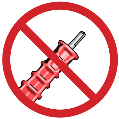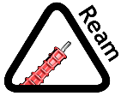

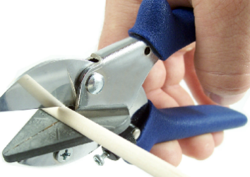**Multi-Cutter**

Need to cut a wooden dowel or plastic strip? Use a multi-cutter. Do not use multi-cutters on metal, or other hard materials. Wear safety glasses when using multi-cutters.

**Innovation**

TeacherGeek allows you to learn and grow with your projects. Start with an example, experiment and redesign it, or create something new from scratch.

**Build Instructions:**

**Step 1:**

Cut Three 55mm (2 1/8in) dowels.

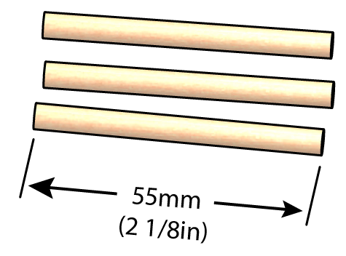

**Step 2:**

Push or tap the dowels into a full connector strip, as shown.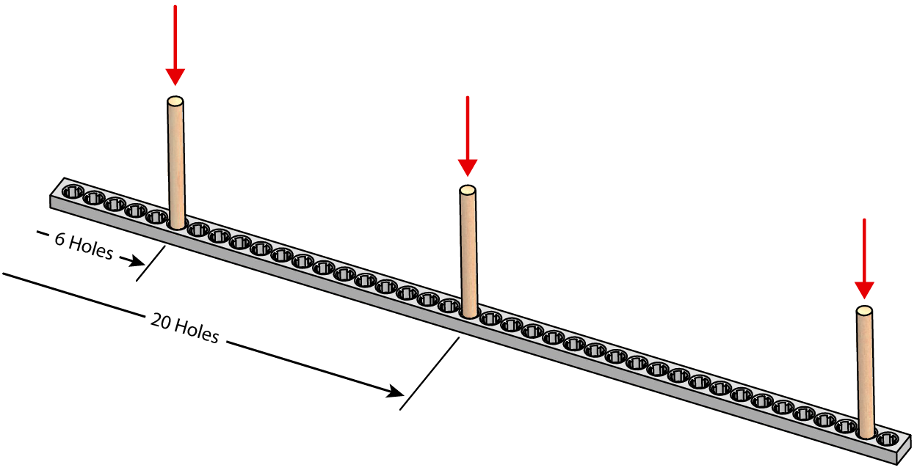

It should look like this when you are done:

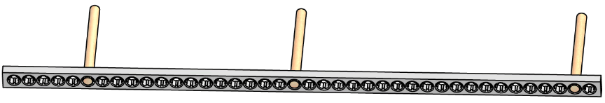

**Step 3:**

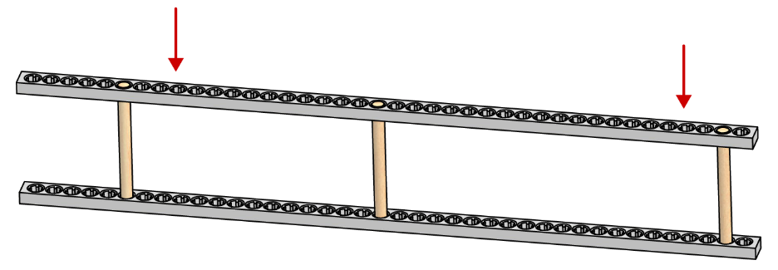Push/tap a second connector strip on to the assembly from Step 2 as shown.

**Step 4:**

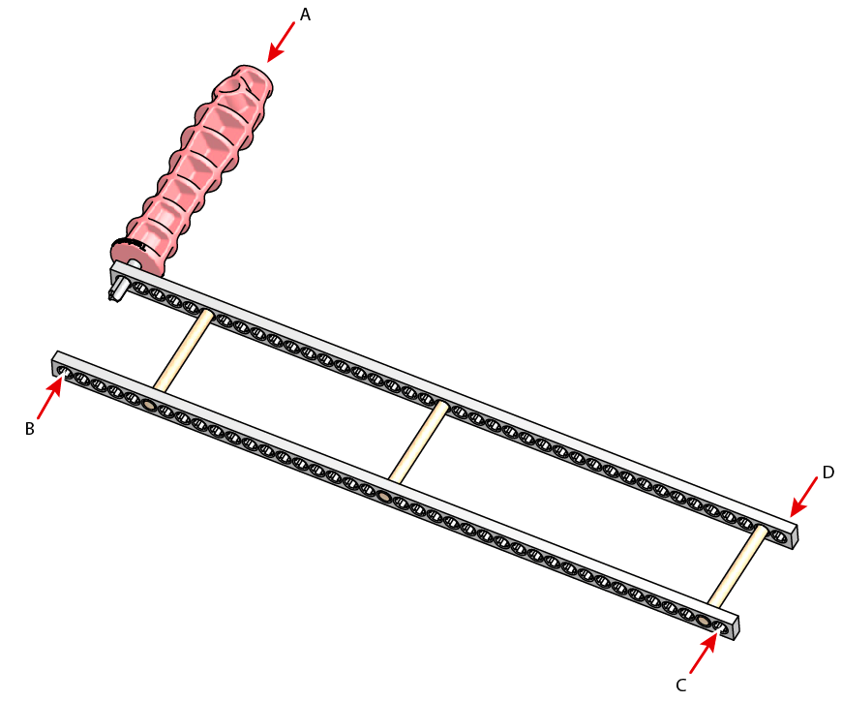Ream holes marked A, B, C and D.

**Step 5:**

Cut two 80mm (3 1/8in) dowels

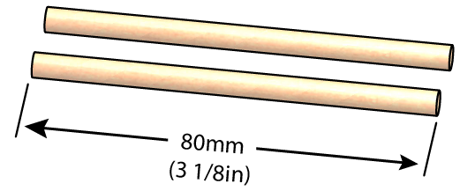

**Step 6:**

Push/tap the dowels from Step 5 into wheels.

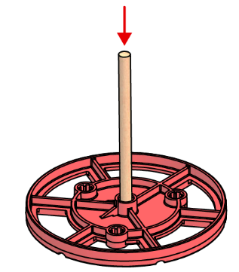

**Step 7:**

Insert the wheel assemblies from Step 6 into the frame from Step 4.

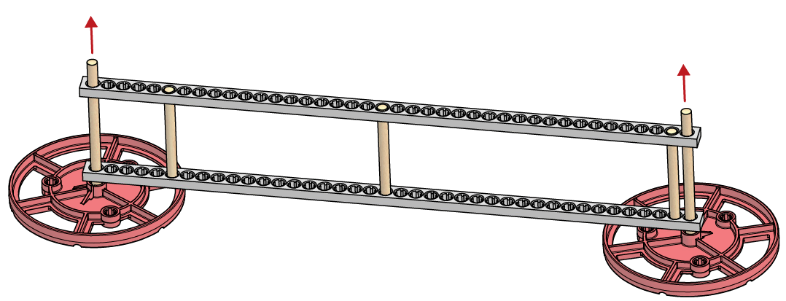

**Step 8:**

Push/tap two more wheels onto the wheel assemblies.

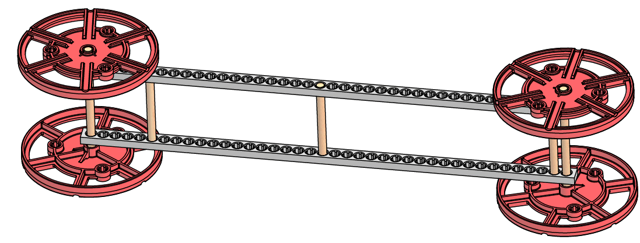

**Step 9:**

Make it roll. Make sure your yeast mobile frame is working properly, and that it will roll with the least resistance. Examine: Friction, Alignment

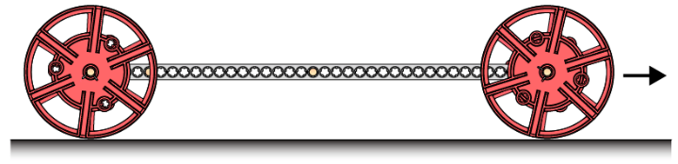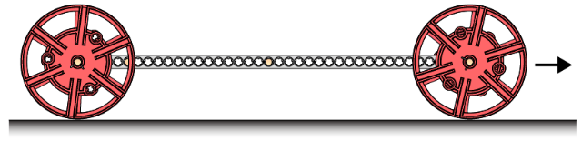

**Step 10:**

Cut two 45mm (2 3/4in) dowels.

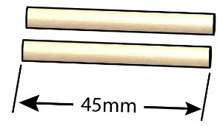

**Step 11:**

Push/tap the dowels from Step 10 into a new full-sized connector strip.

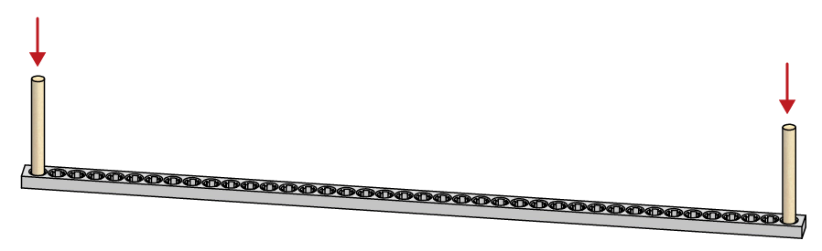

**Step 12:**

Push/tap a new full-sized connector strip onto the dowels from Step 11.

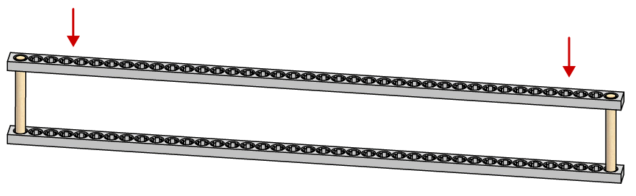

**Step 13:**

Ream holes A, B, C, and D in the frame, and the arm assembly created in Step 12. The reamed holes will become a pivot point (fulcrum) for the lever arm.

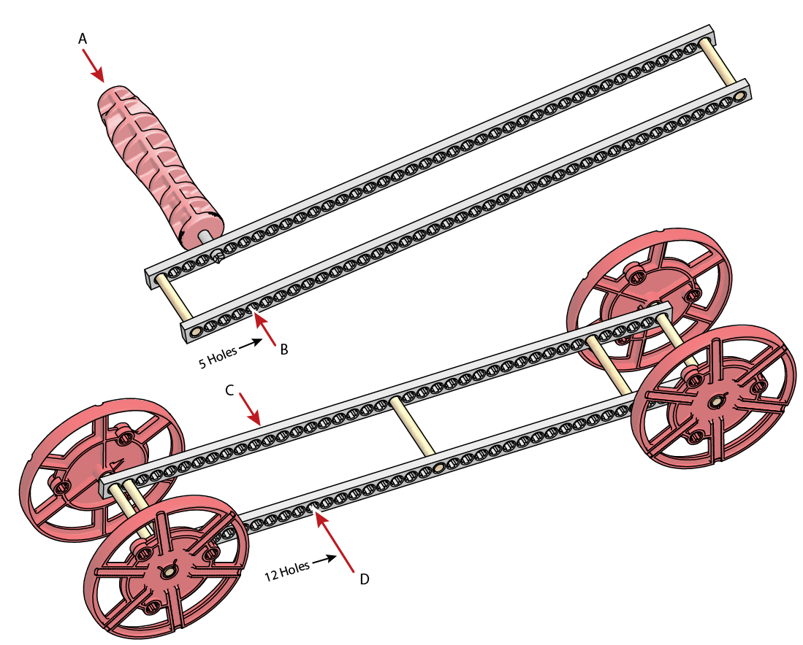

**Step 14:**

Cut one 80mm (3 1/8in) dowel.

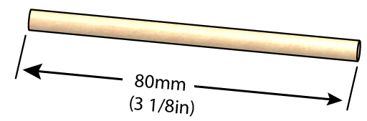

**Step 15:**

Slide the dowel from Step 14 though the holes reamed in Step 13.

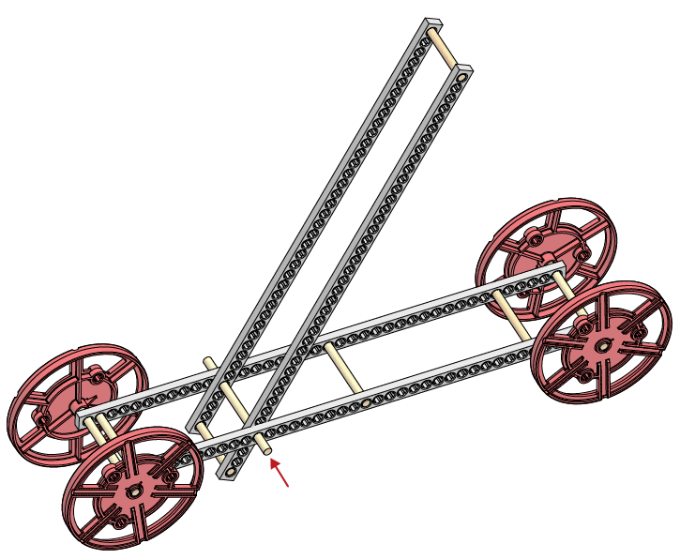

**Step 16:**

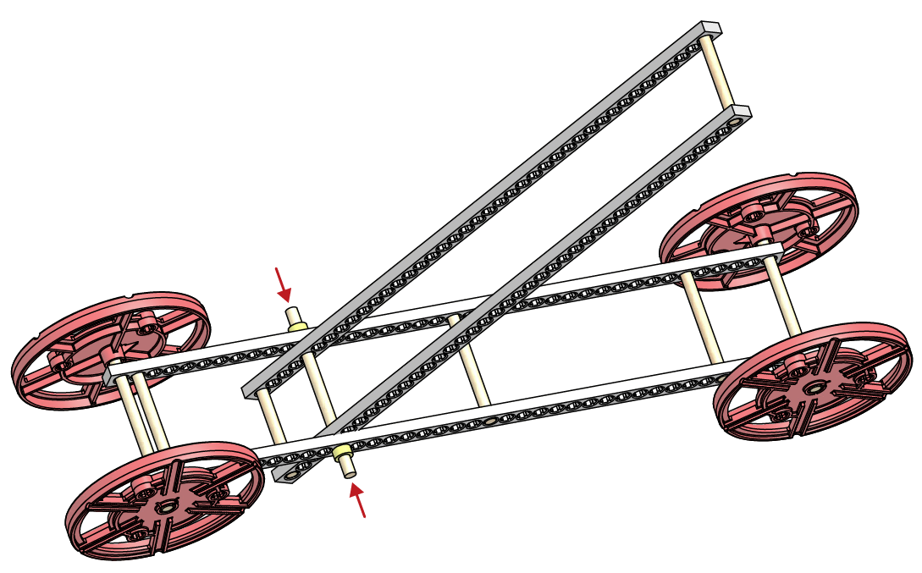Cut two 3mm (1/8in) sections of slide stop and slide them on the ends of the loose dowel.

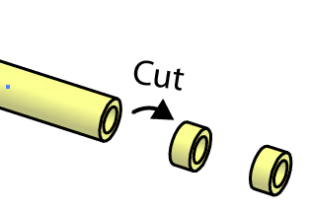

**Step 17: Create the Cylinders**

Repeat steps 17a-17d to create two cylinders.

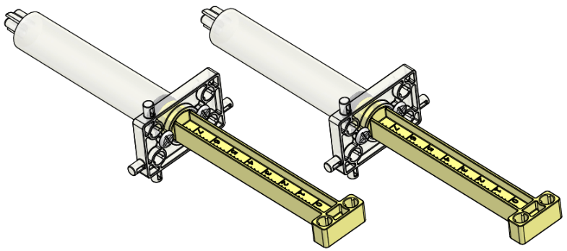

**Step 17a:**

Place the plunger onto the piston.

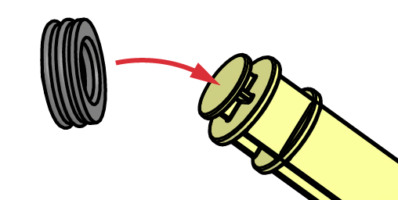

**Step 17b:**

Apply a small amount of silicone grease (best) or vegetable oil around plunger.

Note: Do not use Petroleum lubricants. They will cause the plunger to stick and fail.

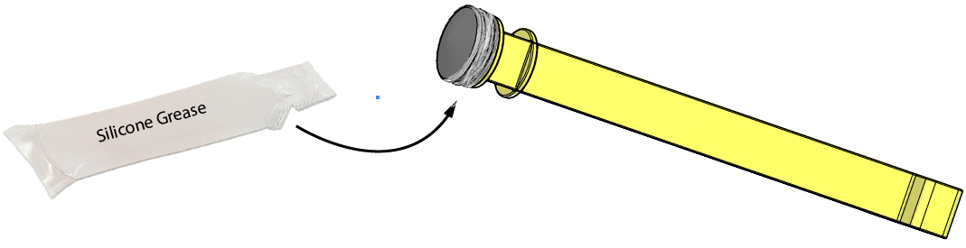

A small amount of silicone grease will lubricate many plungers (a 1cc packet can lubricate over 30 pistons). Save the extra lubricant to use later.

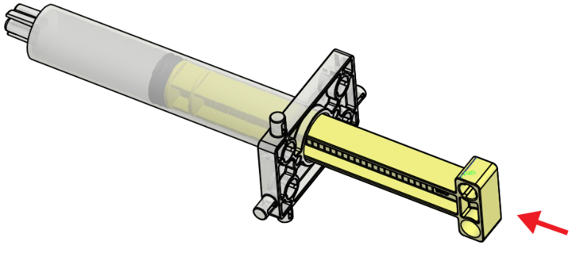**Step 17c:**

1. Make sure the plunger is lubricated! If not, it will get stuck in the barrel.
2. Insert the piston assembly into the barrel. Move the piston in and out to lubricate the barrel.

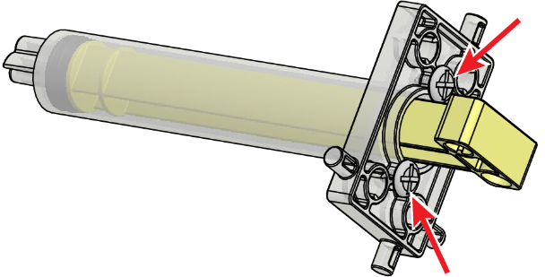**Step 17d:**

Turn two #6 screws into the barrel to keep the piston from coming out.

**Repeat:**

Did you repeat Steps 17a-17d to create two 13ml cylinders?

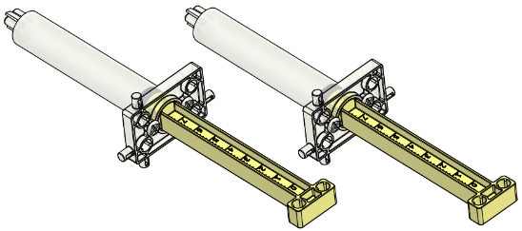

**Step 18:**

Ream the piston holes in a cylinder.

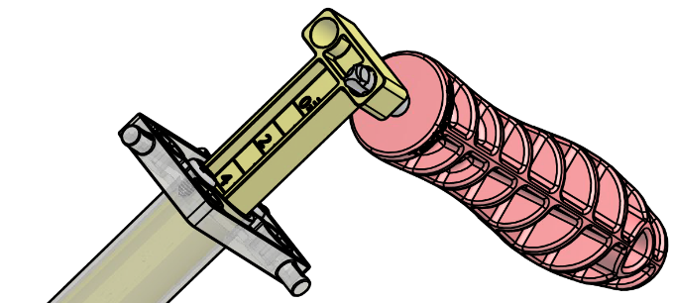

**Step 19:**

Attach the cylinder with the reamed holes to the frame and lever arm. The picture does not show the best place to mount the cylinder. The shown configuration will cause the piston to hit the ground. You need to experiment and find the best place to mount the cylinder.

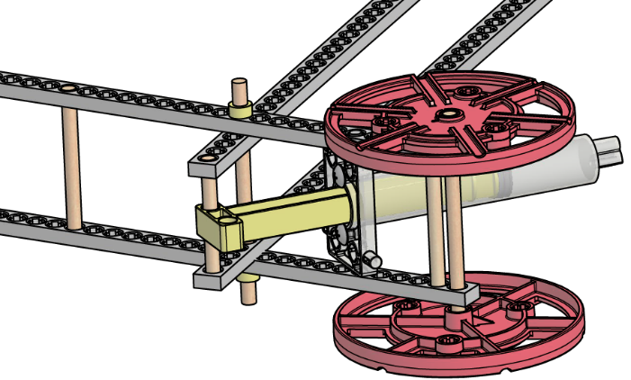

**Step 20:**

Cut 28cm (11in) of tubing 

**Step 21:**

Use the 28cm (11in) section of tubing to connect the cylinders. Experiment: Can you move the lever arm with the loose cylinder? Discover the mechanical advantages, displacement, and fluid power. Extension: Try using water in your cylinders.

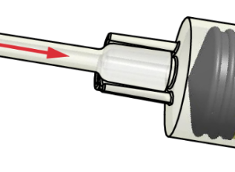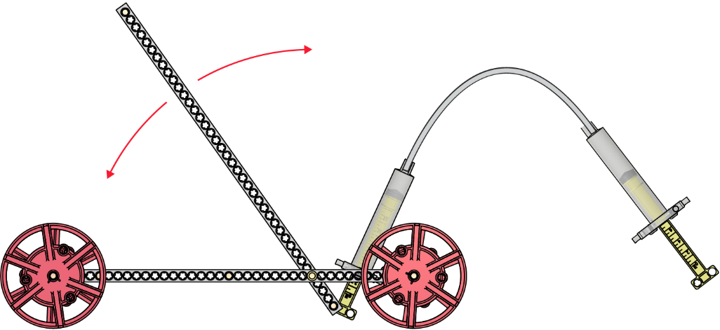

**Step 22:**

Insert a #6 screw into the cylinder tips to keep the tubing from slipping off.

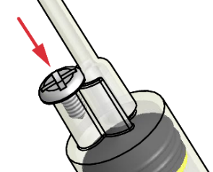

**Step 23:**

Attach a string (not supplied) to the lever and wheel axle. The string should be long enough so that it continues to unwind as the lever arm moves away from the axle. Optional: A stop clip can be put onto the axle to hook the string from the lever arm.

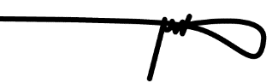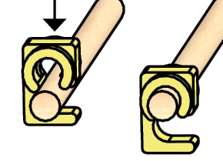 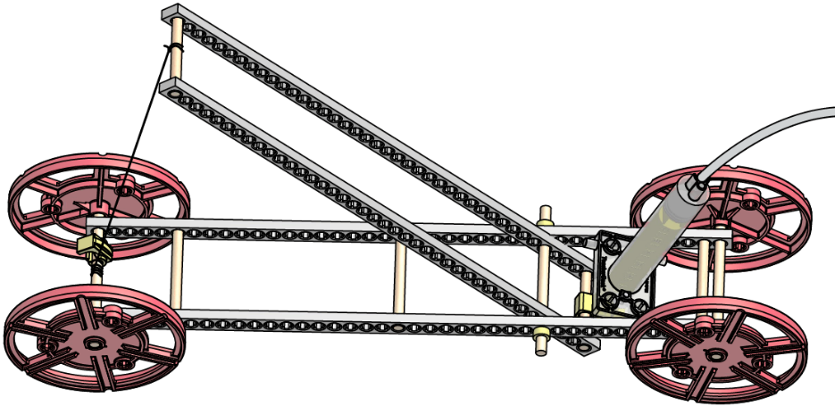

**Step 24:**

Attach the 13cc cylinder to the frame using a screw and nut.

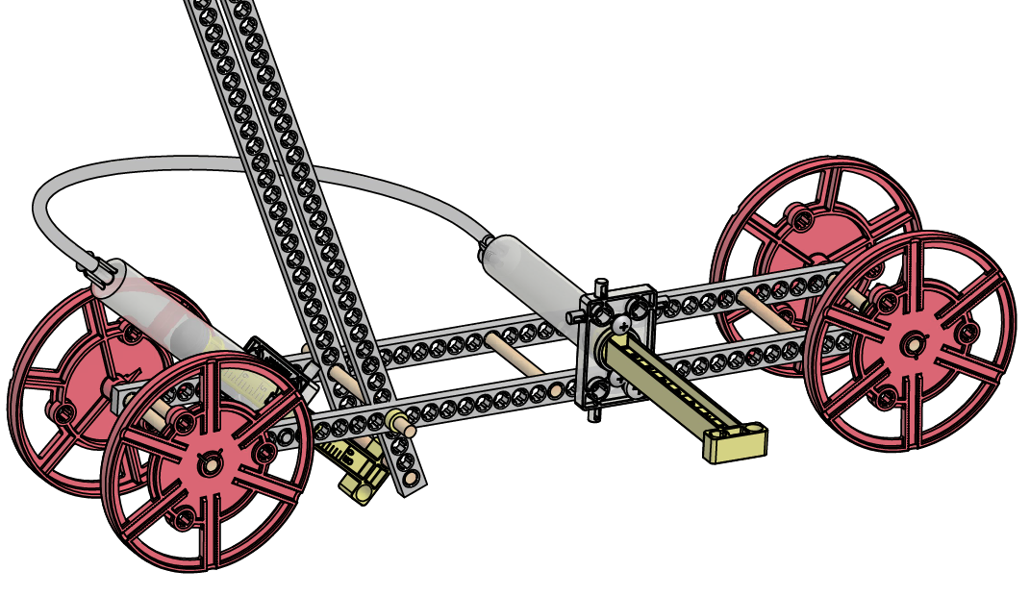

**Make it go…**

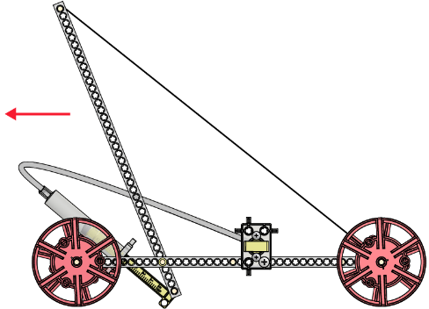Wind the string up on the axle, pulling the lever arm down. Remove the piston from the cylinder on the frame. Add yeast, or other gas producing solution. Quickly put the piston back in and the screws that hold it. The expanding gas should transfer to the lever arm cylinder and power your vehicle. Refer to page one to see how it works.

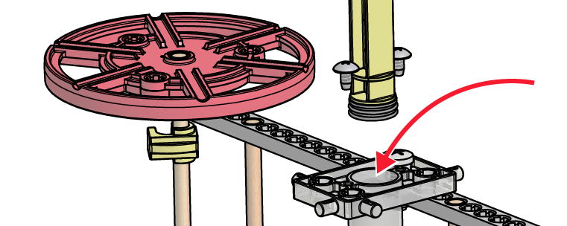

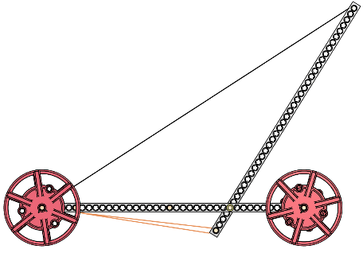**Engineer:** Now it’s time to test, modify and improve your yeast mobile. You have constructed the example design. It is not the best design or configuration. Ideas: Experiment with mechanical advantage by changing where the piston and string attach on the lever. Create a new frame configuration. Develop the ideal yeast solution (food, water, temperature) through scientific method. Rubber bands can be stretched around wheels for traction.

**Extension:** After you are done with your yeast mobile,

try powering it with rubber bands.